1. Essential component of speaker, shown in the figure plays important role in loudspeaker’s performances.

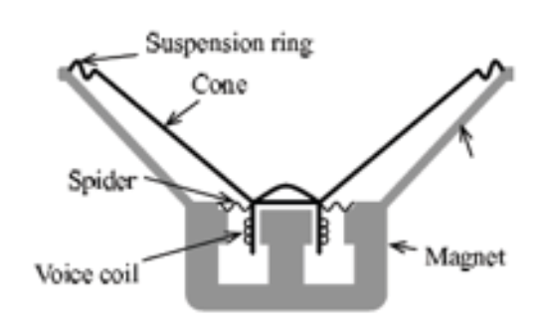

**Voice coil** is a very small coil of thin wire suspended within the magnetic field of a permanent **magnet**. The magnet provides a magnetic reference for the voice coil to operate in. When an analogue signal passes through the voice coil, an electromagnetic field is produced. The electromagnetic force produced by this field opposes the main permanent magnetic field around it and tries to push the coil in one direction or the other. **Cone** (or diaphragm) attached to the voice coil also moves in tandem and cause a disturbance in the air around it.

A larger magnet or bigger voice coil makes more efficient and louder sound, but there isn’t any direct correlation with sound quality. Stiffness of a cone is one of the defining factor of how good a speaker sounds, since a stiffer cone does not dissipate the resonant frequencies on the cone. It allows better dampening, which creates a cleaner sound.

Then there is the speaker’s **spider** and **suspension ring**. They hold cone-voice coil apparatus to the bracket (or frame). The spider controls the mass of the cone while the suspension ring keeps the speaker centered. Spider allows free vertical movement, while fix the horizontal position of the voice coil. It is very important in how well the speaker performs in a given frequency range. Stiffer spiders are generally used for mids and highs while loose spider is needed for deep bass extension.

1. A loudspeaker enclosure is an enclosure in which speaker drivers and associated electronic hardwire are mounted. They have different sizes, shapes, and composite materials.

The primary role of the enclosure is to prevent sound waves generated by rearward-facing surface of the diaphragm of an open speaker driver interacting with sound waves generated at the front of the speaker driver. Because the forward- and rearward- generated sounds are out of phase with each other, any interaction between the two in the listening space creates a distortion of the original sound as it was intended. Enclosure creates a baffle, that blocks the rearward-facing sound. Theoretically, an infinite area of a baffle is needed.

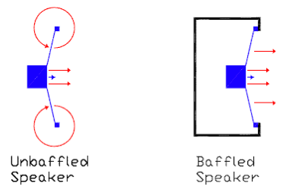

The enclosure also plays a role in managing vibration induced by the driver frame and moving airmass within the enclosure, as well as heat generated by driver voice coils and amplifiers.

If enclosure does not exist, sound waves may distort and the speaker drivers are exposed without any protection.

1. (a) Most loudspeaker use multiple drivers and employ crossover netwroks to rout the appropriate frequency ranges to the different drivers. The **high-pass filter** can be designed with the capacitor, since it has lower impedance for high frequencies. It blocks the low frequencies and let high frequencies through. In similar principle, the **low-pass filter** can be designed with inducteor, which has lower impedance for low frequency. **Band-pass filter** can be designed with a capacitor and inductors in series, blocking both very high and very low frequencies.

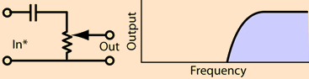

**High-pass filter**

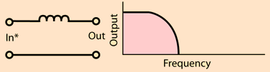

**Low-pass filter**

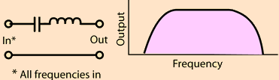

**Band-pass filter**

Using such filters, crossover network splits a given signal into two or three frequency ranges. It is used because most individual loudspeaker drivers are incapable of covering the entire audio spectrum from low to high frequencies with acceptable relative volume and absence of distortion.

(b) Crossover network is combination of capacitors, inductors, and resistors amounting the filter action. (Resistor may be used in parallel with the speaker to decrease the amount of power that goes to it.)

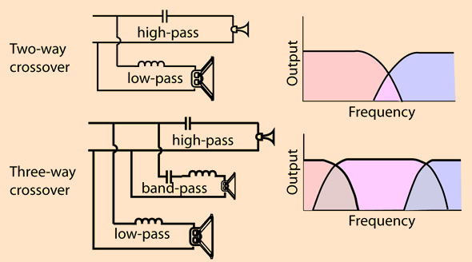

Two-way crossover is composed with high range “tweeter” (high-pass filter), and Base range “woofer” (low-pass filter).

Three-way crossover applies mid-range “squaker” (band-pass filter).

**Reference**

[1] <http://www.electronics-tutorials.ws/io/io_8.html>

[2] <http://www.vertexaudio.com/Cheap-Vs.-Expensive-Speakers-a/276.htm>

[3] <https://en.wikipedia.org/wiki/Loudspeaker_enclosure>

[4] <http://hyperphysics.phy-astr.gsu.edu/hbase/Audio/cross.html#c2>

[5] <https://en.wikipedia.org/wiki/Audio_crossover>